DECISIONS DELEGATED TO OFFICERS

Decision title: | Letting of the whole of St Aldate’s Chambers
Decision date: | 28 November 2022
Source of delegation: | Cabinet, on 14 September 2022, resolved to:  4. Delegate authority to the Executive Director (Development) in consultation with Head of Financial Services / S151 Officer, the Head of Law & Governance and the Deputy Leader (Statutory) – Finance and Asset Management to enter into lease(s) to let the whole of St Aldate’s Chambers in line with the strategy set out in the confidential Appendix 1 or on other terms which fulfil the requirements of S123 Local Government Act 1972.
What decision was made? | Following the authority from Cabinet, to enter into agreement for lease, lease, licence for alterations, and rent deposit deed to let the whole of St Aldate’s Chambers in line with the strategy set out in the confidential Appendix 1 of the report to Cabinet dated 14 September 2022, or other terms that fulfil the requirements of S123 Local Government Act 1972.
Purpose: | Please refer to the Cabinet report titled ‘Future Workplace – Relocation from St Aldate’s Chambers to Oxford Town Hall’ dated 14 September 2022.
Reasons: | The decision enables the lease of the whole of St Aldate’s Chambers, which will permit more efficient use of the Council’s property estate. Further information is contained in the Cabinet report ‘Future Workplace – Relocation from St Aldate’s Chambers to Oxford Town Hall’ dated 14 September 2022.
Decision made by: | Tom Bridgman, Executive Director (Development)
Other options considered: | Not to enter into agreement. This option was rejected as it would not allow the Council to benefit from efficiencies within its property estate. Further information is set out in the Cabinet report.
Documents considered: | Report to Cabinet ‘Future Workplace – Relocation from St Aldate’s Chambers to Oxford Town Hall’ dated 14 September 2022 and associated confidential Appendix 1.
Key or Not Key: | Key (income or expenditure over £500k)
Wards significantly affected: | None
Declared conflict of interest: | None
This form was completed by:  Name & title:  Date: | Alex Miller  Transactions Manager  25/11/2022

Approval checklist

Approver | Name and job title | Date
Decision maker | Tom Bridgman  Executive Director, Development  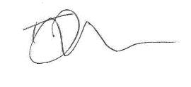 | 28.11.22

Consultee checklist

Senior officer | Jane Winfield  Head of Corporate Property  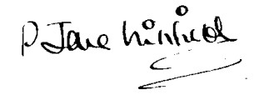 | 28.11.22
Head of Financial Services | Nigel Kennedy  Head of Financial Services  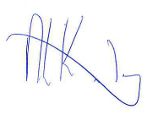 | 28.11.22
Head of Law and Governance | Susan Sale  Head of Law and Governance  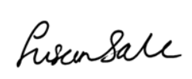 | 28.11.22
Cabinet Member | Councillor Ed Turner, Deputy Leader (Statutory) – Finance and Asset Management | 28.11.22

